**Tutorial 2 : Network Protocols and Communication**

Q1. “Before communicating with one another, individuals must use established rules or agreements to govern the conversation.” Discuss this statement. (6 marks)

* Its purpose is to provide effective communication. Protocols that define a common format and set of rules for exchanging messages between devices must be followed in order for the messages to be successfully delivered and understood. The protocol/rules need to account for:
* An identified sender and receiver
* Common language and grammar
* Speed and timing of delivery
* Confirmation or acknowledgement requirements

Q2 (a) When a web client makes a request to a web server, describe the interaction of protocols based on Figure 1. (8 marks)

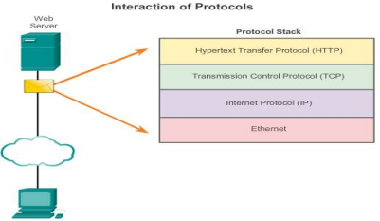Figure 1: Interaction of Protocol

The interaction of protocol refers to the multiple protocols and standards communication with each other to exchange information. Different protocols are working together to ensure messages are received and understood by both parties.

* **Application Protocol** - HTTP defines the content and formatting of the requests and responses exchanged between the client and server.
* **Transport Protocol** - TCP divides the HTTP message into smaller segments. It is also responsible for controlling the size and rate of message exchange.
* **Internetwork Protocol** - IP encapsulating segments into packets, assigning the appropriate addresses, and selecting the best path to the destination host.
* **Network Access Protocol** - Ethernet is a protocol for data link management and the physical transmission of data on the media.

Q3. The Open Systems Interconnection (OSI) reference model is created by the International Standards Organisation (ISO) to develop standards for networks and to facilitate multi vendor equipment interoperability. List the **SEVEN (7)** layers of the OSI model and also describe **ONE** function for each layer. (14 marks)

| *Layer* | *Functions* |
| --- | --- |
| Application | Contains protocol for process-to-process communication |
| Presentation | Ensure information from the sender’s application layer can be read by the receiver’s application layer |
| Session | Establishes, manages and terminates sessions between 2 communicating hosts |
| Transport | Defines services to segment, transfer, and reassemble the data for individual communications between the end devices. |
| Network | Responsible for delivery of individual packets from source to destination (host-to-host delivery possibly across multiple networks) |
| Data Link | Provides transit of data across a physical link by defining the rules about how the physical link is used. (host to host delivery in the same network) |
| Physical | Encode and transmit raw data bits |

Q4. (a) State any ONE (1) advantage and ONE (1) disadvantage of segmentation

*(201603 TAR UC, resit)* (7 marks)

**Advantages**

- Increased efficiency of network communications by sending the message through different

routers if necessary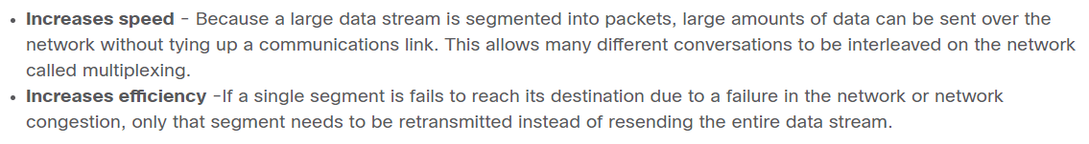

**Disadvantages**

Network application deployment on a company server will become a difficult process as traffic

between segments have been cut off.

Q5. (a) Referring to OSI model, Figure 2 shows the encapsulation of Protocol Data Unit.

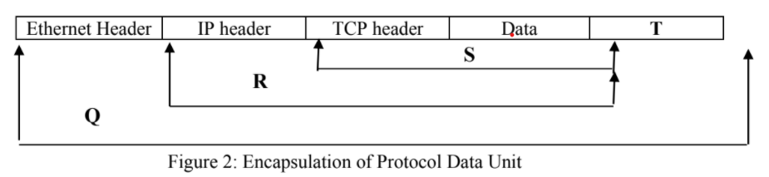

(i) Identify the Protocol Data Unit labeled **Q**, **R**, and **S**: (3 marks)

| Q | Ethernet frame | 1 mark |
| --- | --- | --- |
| R | IP packet | 1 mark |
| S | TCP segment | 1 mark |

(ii) Name the field labeled **T** and describe its function. (3 marks)

* Trailer
* Contains control information for error detection added to the end of PDU.

(b) “When a host needs to send a message to another host in the same network, it must use the router, also known as the default gateway.” Evaluate this statement. (4 marks)

* This is a wrong statement. For same network delivery, the message is not required to be sent to the default gateway.
* When the sender and receiver of the IP packet are on the same network, the data link frame is sent directly to the receiving device.

**Notes : Evaluate -- agree or disagree the statement